Theme/Term | 7 wks History- Vikings- |  |  |  |  |  | 7 wks Geography – Blue Abyss Science- space
writing | 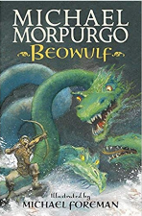  class novel  Beowulf  Micheal Morpurgo |  | 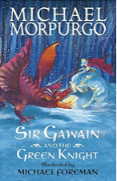  Sir Gawain Micheal Morpurgo |  |  | Real purpose  School poetry competition  Poet study | 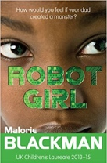  Robot Girl  Malorie Blackman  class novel | 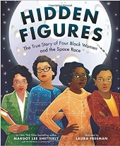  Hidden Figures  Margot Lee Shetterley |  |  | Real purpose
Outcomes | To entertain  Letter of advice, diary entry, own legend |  |  |  |  |  | Write to inform Discussions, debates, dialogue, character comparisons, reviews | Memoir  non-chronological report, formal persuasive letter, informal letter, diary entry, character description |  |  | Write to persuade
reading | Beowulf  Micheal Morpurgo |  |  | 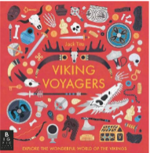  non-fiction  Viking voyagers  Jack Tite |  | 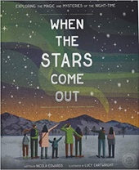  poetry  When the Stars Come Out  Nicola Edwards | Robot Girl  Malorie Blackman |  |  | 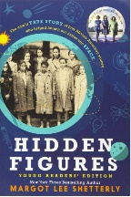  non-fiction  Hidden Figures  Margot Lee Shetterley
Theme/Term | 5 wks History – Victorian Era including Birmingham |  |  |  |  |  | 5 wks Geography- Grow, sow and farm
writing | 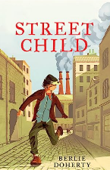  class novel  Street child  Berlie Doherty |  |  |  | Real purpose  School poetry competition  Poetic style |  | 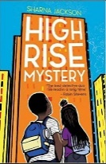  Class novel  High Rise Mystery  Sharna Jackson |  |  |  | Real purpose  Book for class library
Outcomes | To inform Newspaper articles, diary entry, letter |  |  |  |  |  | To entertain  Mystery narrative  Police report, newspaper article, persuasive letter
reading | Street child  Berlie Doherty | 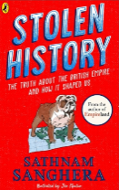  Non-fiction  Stolen history  Sathnam Sanghera |  |  | poetry  The Listeners  Walter de la Mare |  | High Rise Mystery  Sharna Jackson | 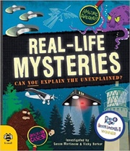  non-fiction  Real-life Mysteries: Can you explain the unexplained?  Susan Martineau and Vicky Barker
Theme/Term | 7 wks History- Early Islamic Civilisation |  |  |  |  |  | 7 wks Geography – Rainforests
writing | 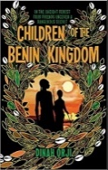  Class novel  Children of the Benin Kingdom  Dinah Orji | 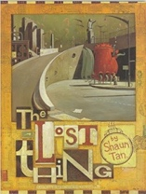  The Lost Thing  Shaun Tan |  |  | Real purpose  School poetry competition  Performance poetry |  | 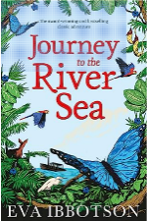  Class novel  Journey to the river sea  Eva Ibbotson | 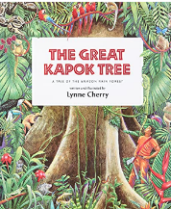  The Great Kapok Tree  Lynen Cherry |  |  | Real purpose  Persuasive letter to Cadbury’s – palm oil
Outcomes | To inform  Non-chronological report  Informal letter, diary entry, survival guide, story summary |  |  |  |  | Diaries, formal letters, adverts, character and setting descriptions, | To entertain  Letters, poetry,timetables, diary entry, narrative
reading | Class novel  Children of the Benin Kingdom | 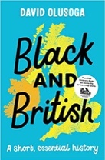  non-fiction  Black and British: A short, essential history  David Olusoga |  |  | 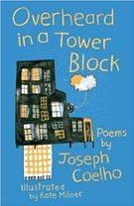  poetry  Overheard in a Tower Block  Joseph Coelho |  | Journey to the river sea  Eva Ibbotson |  | 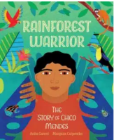  non-fiction  Anita Ganeri & Margaux Carpentier

