Theme/Term | 7 wks History- Anglo Saxons Scots |  |  |  |  |  |  | 7 wks Geography – interconnected world
writing | 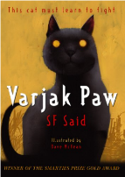  class novel  Varjak Paw  A F Said |  |  |  |  |  | Real purpose  School poetry competition  Poet study | 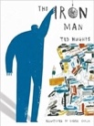  class novel  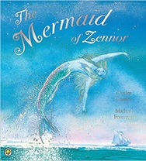  The Iron Man  Ted Hughes | 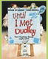  Until I Met Dudley  Roger McGough and Chris Riddell |  |  | Real purpose
Outcomes | To inform- diary entry , newspaper report  To entertain- poem, narrative |  |  |  |  |  |  | To entertain  Mystery narratives  Character descriptions, short news reports, letters of advice, menus (using descriptive devices), poetry | To inform  Two explanation texts - formal and informal  Letters, short explanatory paragraphs
reading | class novel  Varjak Paw  A F Said |  |  | Non-fiction  Newspapers |  |  | 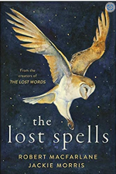  Poetry  The lost spells | The Iron Man  Ted Hughes |  |  | 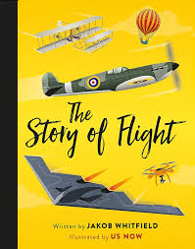  Non-fiction  The Story of Flight  Jakob Whitfields
Theme/Term | 5 wks History – Windrush inc Birmingham |  |  |  |  |  |  | 5 wks Geography- USA road trip
writing | 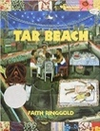  Tar Beach  Faith Ringgold | Varmints  Helen Ward  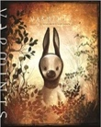 |  |  |  | Real purpose  School poetry competition  Poetic style |  | 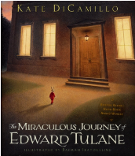  class novel  The miraculous journey of edward Tulane  Kate Di Camillo |  |  |  | Real purpose  Persuasive text- competition to choose which animal to adopt
Outcomes | To entertain Own version playscripts  Character descriptions, formal letters, book reviews, dialogue (direct speech), retellings | To inform Explanations  Descriptive comparisons, retellings, setting descriptions, poetry
reading | 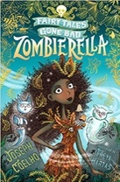  class novel  Zombierella  Joseph Coelho | 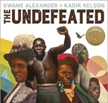  poetry  Undefeated  Kwame Alexander |  |  |  |  |  | class novel | 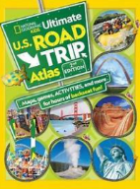  non-fiction |  |  | 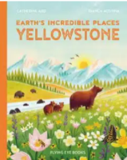  non-fiction  Yellowstone  Catherine Ard
Theme/Term | 7 wks History- Greeks |  |  |  |  |  |  | 7 wks Geography – Investigating our world
writing | 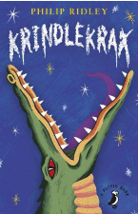  class novel  Krindlekrax  Philip Ridley | Poetry  Jabberwocky  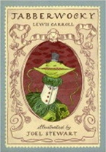  Lewis Carroll |  |  |  | Real purpose  School poetry competition  Performance poetry |  | 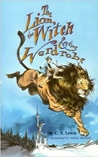  The Lion the Witch and the Wardrobe  C. S. Lewis  Class Novel |  |  |  | Real purpose
Outcomes |  |  |  |  | To entertain  Nonsense poems  Performance poetry, explanatory descriptions |  |  | To entertain  Own version narratives (set in other worlds)  Poems, eyewitness reports, an imaginary conversations, writing in role
reading |  | 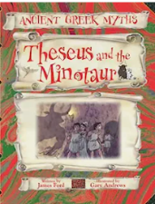  Theseus and the minotaur |  |  |  | 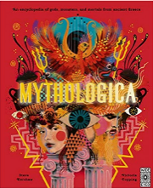  non-fiction  Greek Myths

